ACTIVITY: STOVE AND ITS ACESSORIES MAINTENANCE
_____________________________________________________________________
➢ Objective : - Safe Maintenance of Stoves & its Accessories.
➢ Scope : - Blast Furnace Accessories
➢ Ref. : -
- Responsibility : - Engineer In-charge and workmen at job

PPE –s to be used :

Safety helmet, Safety Shoes, Hand gloves, Ear muffler, mask & Safety goggle

Work No 1 : HBS checklist
Work No 2 : Maintenance of Valves

Work No 3 : Valve changing

Work No 4 : Valve leakage arresting

Work No 5 : Hydraulic cylinder changing
Work No 6 : Trunion bearing changing

Work No 7 : Valve Seal changing
Work No 8 : HBV counter weight adjusting and chain/rope changing
Work No 9 : Valve cleaning
Work No 10 : HBV hose changing (Water)
Work No 11 : Valve hydraulic hose changing
Work No 12 : Valve hydraulic oil leakage arresting

Work No 13 : RV actuator changing

Work No 14 : Hydraulic pipeline painting
Work No 15 : Checking of chain/rope for counter weight
Work No 16 : Regulating valve changing
Work No 17 : Accumulator maintenance
Work No 18 : Welding on stove shell
Work No 19 : Commissioning of GPH/APH in BF#1
Work No 20 : CPV rope changing
Work No 21 : HBV Bonnet replacing
Work No 22 : CPV spring support (Jelly-Belly Washer) Changing.
Work No 23 : APH/GPH pipes cleaning during SD
Work No 24 : Chimney valve Top bonnet replacement.
Aspect-Impact

Oil Spillage | Land contamination
Oil traced waste generation | Land contamination & Resource Depletion
Fire | Air pollution SP42
Scrap generation | Resource depletion
Fumes | Health

HAZARDS IDENTIFIED
Physical Hazard
• Pressure, temperature
• Explosion in accumulators.
• Explosion inside stove while doing cutting/welding activity.
• itching due to handling of glass wool which is used for insulation in HBS.
• Steam
Mechanical Hazard
• Trapping between two objects,
• Fall of material, hammer, tools, slinged items, bolts, wedges etc
• Fall of person from platform, height
• Entanglement
• Impact of moving / slinged items
• Slipping and falling due to oil spillage.
• overturning of valve in slanged condition due to sifting of centre of gravity
Electrical hazard
• Shock
Chemical hazard
• Co gas poisoning & Fire
Biological Hazard
• Bee sting
Behavioral hazard
• Alcoholism
• Non usage of PPE’s
• Casual approach while working

Before carrying out all above activities –

- Inspection for Honey Bee Hive to be done.

- CO level should be less than 50 ppm.

Work No 1: HBS checklist

Guidelines to do daily checklist of HBS:

- Pep talk to be given on daily basis.
- PPE’s to be used-
- Safety Helmet
- Safety Shoes
- Hand Gloves
- Ear Plug
- Safety Goggles
- Carry 2 nos. CO monitors.
- Inform control room engineer and take the key of HBS gate.
- Do the checklist thoroughly according to the mentioned points in HBS checklist book.
- Once the checklist of HBS is done, close the HBS gate.
- Inform control room engineer & handover key of HBS gate.
Do’s:
- Carry 2 nos CO monitor.
- Use required PPE’s.
- Use staircase with 3 points contact.
- Mind head while walking in HBS area.
- Follow proper path.
Don’ts:
- Touch the HBS valves as well as any rotating equipment.
- Keep apparel loosen.
- Cross the equipment to go other side.

Work No 2: Maintenance of Valves

- Gland changing/gland tightening of GSSV and GSV

To be done only during plant shutdown after water sealing of stove Gas line and steam purging.

a) Take production clearance and work permit for changing of glands.
b) Take Electrical Isolator shutdown from electrical engineer.
c) Ensure that stove is in isolated stage and water seal to be done stove gas line.
d) Close the ball valve from power pack stand of respective stove valves and put the Mechanical isolation lock on each valve.
e) Check the Co gas level before starting of job and should start the job only if Co level is within limit (below 50 ppm).
f) Loosen the gland pusher and remove old rope.
g) Fit new graphited square rope 16mm by cutting to required size and tighten the gland pusher.
h) Remove the Mechanical isolation lock and open the ball valve from power pack.
i) Clear Electrical Isolator Shutdown.
j) Take valve trial
k) Close work permit.
l) Give clearance to production.

- Gland changing for CASV and CV

a) Take production clearance and take work permit for gland changing.
b) Take Electrical Isolator shutdown from electrical engineer.
c) Ensure that stove is isolated and withdrawn from auto mode PLC.
d) Close the ball valve from power pack stand of respective stove valves and put the Mechanical isolation lock on each valve.
e) Check the CO level before starting of job and should start the job only if CO level is within limit (below 50 ppm).
f) Loosen the gland pusher and remove old rope.
g) Fit new graphite square rope 16mm by cutting to required size and tighten the gland pusher.
h) Remove the Mechanical isolation lock and open the ball valve from power pack.
i) Clear Electrical Isolator Shutdown.
j) Take valve trial.
k) Close work permit.
l) Give clearance to production.

- Gland changing for CBV, CBBV and HBV

a) Gland changing job can be taken only when there is shutdown.
b) Take production clearance and take work permit for gland changing.
c) Take Electrical Isolator shutdown from electrical engineer.
d) Ensure that stove is isolated and withdrawn from auto mode PLC.
e) Close the ball valve from power pack stand of respective stove valves and put the Mechanical isolation lock on each valve.
f) Loosen the gland pusher and remove old rope.
g) Fit new graphite square rope 16mm by cutting to required size and tighten the gland pusher.
h) Remove the Mechanical isolation lock and open the ball valve from power pack.
i) Clear Electrical isolator Shutdown.
j) Take valve trial
k) Close work permit.
l) Give clearance to production.

Work No 3: Valve changing

- Valve changing - GSSV

To be done only during plant shutdown after water sealing of stove Gasline and steam purging.

a) Take work permit from production for changing of valve.
b) Ensure that the stove is isolated and withdrawn from PLC auto mode.\
Ensure the GSSV is close
c) Isolate the stove from gas line by doing water seal. And do the steam purging of gas line between the water seal and stove.
d) Blank the gas line just above the GRV.
e) Close the hydraulic power pack stand shutoff valve of respective stove with the main shut off valve of the stand and put the Mechanical isolation lock on each valve.
f) Take Electrical Isolator shutdown from electrical engineer.
g) Ask electrical to remove the limit switches.
h) Remove hydraulic hoses; mark the direction on the hoses for opening and closing and also put plug for the hoses. Collect the oil in an oil-can while opening the hoses.
i) Remove the reducer above GSSV by using chain block of min 2T capacity.
j) Sling it properly to lifting lugs and remove the valve.
k) Remove old gasket and clean the flanges
l) Shift old valve at side and fix the overhauled tested valve. Check the flow direction arrow.
m) Place new gaskets (asbestos gasket 3mm style 54 or equivalent) and tighten the bolts fully of bottom flange.
n) Fix the reducer, insert gasket and tighten the bolts
o) Give electrical connection and connect the hoses. Clear electrical isolator shutdown.
p) Remove the Mechanical isolation lock and open the valves in power pack.
q) Open the bottom inspection door to check disc.
r) Take trials, set the limit switches.
s) Remove stove gas line blank and change the gasket rope for flanges.
t) Close work permit.
u) Give clearance to production.

B Valve changing - GSV

To be done only during plant shutdown after water sealing of stove Gas line and steam purging.

a) Take work permit from production for changing of valve.
b) Ensure that the stove is isolated and withdrawn from PLC auto mode.
c) Isolate the stove from gas line by doing water seal. And do the steam purging of gas line between the water seal and stove.
d) Blank the gas line just above the GRV.
e) Close the hydraulic power pack stand shutoff valve of respective stove with the main shut off valve of the stand and put the Mechanical isolation lock on each valve.
f) Ensure GSV is close
g) Take Electrical Isolator shutdown from electrical engineer
h) Ask electrical to remove the limit switches.
i) Remove hydraulic hoses; mark the direction on the hoses for opening and closing and also put plug for the hoses.
j) Collect the oil in an oil-can while opening the hoses.
k) Then remove valve by slinging it properly to lifting lugs with the help of chain block (capacity 2T).
l) Remove old gasket and clean the flanges.
m) Shift old removed valve at side and fix the overhauled tested valve. Check the flow direction arrow.
n) Place new gaskets (asbestos gasket 3mm style 54 or equivalent) and tighten the bolts fully of bottom flange.
o) Give electrical connection and connect the hoses.
p) Clear electrical isolator shutdown.
q) remove the Mechanical isolation lock and open the ball valve from power pack.

r) Open the bottom inspection door to check disc while setting valve for fully open and fully closed condition.
s) Remove stove gas line blank and change the gasket rope for flanges
t) Take trials, set the limit switches.
u) Close work permit.
v) Give clearance to production.

- Valve changing - CASV

a) Furnace shutdown is required for changing this valve.
b) Take work permit from production for changing of valve.
c) Ensure that the stove is isolated and withdrawn from PLC auto mode.
d) Isolate the stove from gas line by doing water seal. And do the steam purging of gas line between the water seal and stove.
e) Blank stove gas line just above the GRV.
f) Ensure CASV is close.
g) Close the hydraulic power pack stand shutoff valve of respective stove with the main shut off valve of the stand and put the Mechanical isolation lock on each valve.
g) Take Electrical Isolator shutdown from electrical engineer.
h) Ask electrical department to remove the limit switches.
i) Remove hydraulic hoses, mark the direction on the hoses for opening and closing and also put plug for the hoses.
j) Collect the oil an oil-can while opening the hoses.
k) Then remove valve by slinging it properly to lifting lugs with the help of chain block (2T capacity).
l) Remove old gasket and clean the flanges
m) Shift old removed valve at side and fix the overhauled tested valve. Check the flow direction arrow.
n) Place new gaskets (asbestos gasket 3mm style 54 or equivalent) and tighten the bolts fully of bottom flange.
o) Give electrical connection and connect the hoses. Clear electrical isolator shutdown.
p) Remove the Mechanical isolation lock and open the ball valve from power pack.

q) Open the bottom inspection door to check disc while setting valve for fully open and fully closed condition.
r) Take trials. Set the limit switches.
s) remove stove gas line blank.
t) Close work permit.
u) Give clearance to production.

- Valve changing - CBV & CBBV

- Furnace shutdown is required for changing these valves.
b) Take work permit from production for changing of valve.
c) Ensure that the stove is isolated and withdrawn from PLC auto mode.
d) Water seal the respective stove and also steam purge the gas line.
e) Isolate the stove from gas line by doing water seal. And do the steam purging of gas line between the water seal and stove.
f) Blank the stove gas line just above the GRV.
g) Ensure that the CBV/CBBV is close.
h) Close the hydraulic power pack stand shut-off valve of respective stove with the main shut-off valve of the stand and put the Mechanical isolation lock on each valve.
i) Take Electrical Isolator shutdown from electrical engineer
j) Ask electrical department to remove the limit switches.
k) Remove hydraulic hoses, mark the direction on the hoses for opening and closing and also put plug for the hoses.
l) Collect the oil in the can while opening the hoses.
m) Then remove valve by slinging it properly to lifting lugs with the help of chain block (2T capacity).
n) Remove old gasket and clean the flanges
0) Shift old removed valve at side and fix the overhauled tested valve. Check the flow direction arrow.
p) Place new gaskets (asbestos gasket 3mm style 54 or equivalent) and tighten the bolts fully of flanges.
q) Give electrical connection and connect the hoses. Clear electrical isolator shutdown.
r) Remove the Mechanical isolation lock and open the valves in power pack.
s) Open the bottom inspection door to check disc while setting valve for fully open and fully closed condition.
t) Take trials, set the limit switches
u) Remove stove gas line blank.
v) Close work permit.
w) Give clearance to production.

E. Valve changing – Chimney Valve

1. Take work permit from production for changing of valve.
2. Isolate stove of which chimney valve is to be replaced. Ensure that the stove is isolated and withdrawn from PLC auto mode.
3. Isolate the stove from gas line by doing water seal. And do the steam purging of gas line between the water seal and stove.
4. Blank the gas line just above the GRV.
5. Take electrical shutdown of all valves (to be done for CBV, CBBV, GSV, GSSV, CASV and HBV)
6. Close the hydraulic power pack stand shutoff valve of respective stove with the main shut off valve of the stand and put the Mechanical isolation lock on each valve.
7. Weld rod on top of the chimney valve stem to avoid seat getting opened.
8. Remove and loop the hose pipe connections of chimney valve. Mark the direction on the hoses for opening and closing and also put plug for the hoses.
9. Collect the oil in the can while opening the hoses.
10. Remove the hydraulic cylinders of chimney valve.
11. Remove the counterweight of the valve.
12. Dismantle top platform of chimney valve so that CV can be removed without any obstructions.
13. If required, remove the HBS barricading so that the there will be more clearance for moving the crane.
14. Loosen all bolts of CV flange on both the sides by keeping 5 bolts on either side.
15. Ensure that production isolates one stove and other stove is taken on blast and ID fan is stopped.
16. In above condition, with coordination of production, lower CV first to ensure it is free from flanges and then lift to remove CV out by crane of min 20 T capacity. Remove valve by slinging it using the valve lifting arrangement. In case of HBS 1 BF#1 and HBS 3 BF2, the crane can be put from the PCM 1 and PCM 4 sides respectively as it gives extra clearance for moving the crane closer towards the valve. Also in case of BF 2 HBS 3, the valve can be removed by sliding it towards PCM 4 side. For all the other stoves the valve will have to be lifted up by 1.5 mtr and then should be taken out.
17. Coordinate with production and stop all jobs near the valve whenever changeover of other stoves takes it.
18. Fix 3mm plate dummy on waste gas flange and stove flange.
19. In this condition, clearance can be given to production to take other stoves ON GAS and ON BLAST.
20. Repeat step no. 14 to clean flange for putting gaskets. Ensure that cleaning is not carried out by standing in front of the duct opening. Cleaning to be done from sides.
21. Repeat step no 14 to fit the valve back in position. Check the flow direction arrow.
22. The bottom inspection flanges of the valve should be kept in open condition so as to prevent the stove from getting pressurized in case any of the valves becomes passing.
23. Ensure that the new valve is locked with rod so that it does not open.
24. Once the valve is fitted in position and both side flanges minimum 5 bolts are put, clearance can be given to production to take the other two stoves on blast and on gas.
25. Place new gaskets (3mm CAF gaskets, AMJ 321 style) on chimney duct side tighten the bolts fully and then place gasket on stove side and tighten the bolts fully.
26. Tighten all the bolts, install cylinders, fix the hoses, limit switches and platform.
27. Put back the hydraulic pipeline after ensuring that the pipe is not chocked. The pipes should be clamped properly to avoid jerking during operation.
28. Check for proper tightness of the wedge seat flange at the middle of the valve.
29. Install the counterweight for the new valve.
30. Clear electrical shutdown remove the Mechanical isolation lock and open the manual valves in power pack, and take trials in presence of production, electrical and instrumentation.
31. Set the limit switches for port valve closing, port vale opening and disc opening.

32. Check disc while setting valve for fully open and fully closed condition.
33. Port valve, which equalizes the stove pressure, must be set for full opening and full closing. While setting, ensure that the disc doesn’t get lifted up from its seat until the port valve full open limit switch gets cut.
34. Take trials 4 to 5 times and ensure that valve disc is moving in the guide bar.
35. Weld stoppers to prevent the valve from over travelling from fully open and fully closed positions.
36. Once the trials are over, remove stove gas line blank, clear the work permit and inform production to take stove in line.
37. After taking the stove online, check for leakage through the flanges and wedge seat flange. Checking will have to be done when the stove is ON BLAST as pressure will be high during this time. Also check for oil leakages from hydraulic cylinder and pipeline.
38. Keep the stove in ON BLAST condition along with the other stove which is previously ON BLAST for 15 mins. If there is no leakage, then isolate the other stove.
39. Check the bolt tightness once again after 2 hours.

F. Valve changing HBV

a) This activity has to be taken up after shutdown of blast furnace.
b) Check the hoist for operation and also wire rope condition.
c) Take work permit from production for changing of valve.
d) Ensure that the stove is isolated and withdrawn from PLC auto mode.
e)
Isolate the stove from gas line by doing water seal. And do the steam purging of gas line between the water seal and stove.
f) Blank the gas line just above the GRV.
g) Ensure that the HBV is close.
h) Close the hydraulic power pack stand shutoff valve of respective stove with the main shut off valve of the stand and put the Mechanical isolation lock on each valve.

i) Take Electrical Isolator shutdown from electrical engineer.
j) Close cooling water valves of hot blast valve and start removing the hoses of disc.
k) Ask electrical department to remove the limit switches.
l) Remove hydraulic hoses, mark the direction on the hoses for opening and closing and also put plug for the hoses.
m) Collect the oil in the CAN while opening the hoses.
n) Compress expansion bellow and remove the spiral gasket.
o) Then remove valve by using the lifting attachment, which is fabricated for removing HBV with the help of 5T hoist.
p) Use proper sling 25 mm 2mts long for lifting the valve.
q) Lower old HBV and then lift the new valve by using the lifting arrangement.
r) Place the valve and put bolts on both sides on the lower half.
s) Fix the spiral gasket on stove side and tighten the bolts.
t) Then place spiral gasket carefully on furnace side and loosen the expansion bellow both and then tighten the flange bolts.
u) Tighten the flange bolts fully and give water connecting for the valve.
v) Check the water flow through the outlet pipe
w) Connect the hoses and also ask the electrical to give limit. Clear electrical isolator shutdown.
x) Remove the Mechanical isolation lock and open the valves in power pack.

x) Take trial and set valve for full opening and closing.
y) Remove stove gas line blank.
z) Close work permit & give clearance to production.

Work No 4: Valve flanges leakage arresting

a) Check the CO level before starting of job and should start the job only if CO level is within limit (below 50 ppm).
b) Check if the bolts are loose. Tighten if required.
c) If still leakage is not stopping follow the valve changing procedure and change the gasket.

Work No 5: Hydraulic cylinder changing

a) Take work permit from production for changing of cylinder.
b) Ensure that the stove is isolated and withdrawn from PLC auto mode.
c) Close the hydraulic power pack stand valve of respective stove with the main valve of the stand and put the Mechanical isolation lock on each valve
d) Take Electrical Isolator shutdown of respective valve from electrical engineer
e) Check the CO level before starting of job and should start the job only if CO level is within limit (below 50 ppm).
f) Remove hydraulic hoses, mark the direction on the hoses and put plug for the hoses.
g) Remove the pin of cylinder connecting valve.
h) Remove end trunion flanges and change the cylinder with tested and tagged cylinder.
i) Give hosepipe connection to the cylinder.
j) Remove the Mechanical isolation lock and open the valves in power pack.
k) Clear the electrical isolator shutdown.
l) Take trial and check for valve full opening and closing by removing the bottom inspection flange.
m) Clear the work permit

Work No 6: Trunion bearing changing

a) Take work permit from production for changing of bearing of trunion.
b) Ensure that the stove is isolated and withdrawn from PLC auto mode.
c) Close the hydraulic power pack stand valve of respective stove with the main valve of the stand and put the Mechanical isolation lock on each valve
d) Take Electrical Isolator shutdown of respective valve from electrical engineer.
e) Check the CO level before starting of job and should start the job only if CO level is within limit (below 50 ppm).
f) Remove end trunion flanges and change the bearings.
g) Fit the trunion flanges.
h) Remove the Mechanical isolation lock and open the valves in power pack.
i) Clear the electrical isolator shutdown
j) Take trial and check for valve.
k) Clear the work permit.

Work No 7: Valve Seal changing

- Valve soft seal changing for GSSV

a) Furnace shut down is required for changing of this valve
b) Take work permit from production for changing of valve.
c) Ensure that the stove is isolated and withdrawn from PLC auto mode.
d) Water seal the stove and also steam purge the gas line.
e) Blank the respective stove water seal.
f) Valve should be in close condition.
g) Close the hydraulic power pack stand valve of respective stove with the main valve of the stand and put the Mechanical isolation lock on each valve
h) Take Electrical Isolator shutdown from electrical engineer.
i) Remove the reducer above GSSV by using chain block.
j) Open the valves in the hydraulic power pack and then open the GSSV.
k) Close the valves in the power pack.
l) Lock the counter weight lever with sling & D-shackle/Chain pulley block so that valve should not close in case of power failure.
m) Remove the soft seal and replace it with new seal.
n) Take trial for full closing and check if the valve is seating fully by putting filler gauge.
o) Place gasket properly and fix the reducer.
p) Tighten the flanges and remove the lock of counter wt.
q) Remove water seal blank and change the gasket rope for flanges.
r) Tighten the bolts fully.
s) Clear the electrical isolator shutdown.
t) Remove the Mechanical isolation lock and open the valves in power pack.
u) Take trial.
v) Clear work permit and give clearance.

- Valve soft seal changing for CBBV

Furnace shut down is required for changing of this valve

a) Take work permit from production for changing of valve.
b) Ensure that the stove is isolated and withdrawn from PLC auto mode.
c) Water seal the respective stove and also steam purge the gas line.
d) Close the hydraulic power pack stand valve of respective stove with the main valve of the stand and put the Mechanical isolation lock on each valve
e) Take Electrical Isolator shutdown from electrical engineer.
f) Remove the bend and keep the bolts properly.
g) Remove the seal-retaining ring and remove the seal.
h) Replace with new seal and tighten the retaining ring.
i) Remove the Mechanical isolation lock, clear the electrical shutdown and open the valves in power pack than take trail.
j) Check for full closing with the help of filler gauge 0.02mm
k) Check the gasket, if OK fit the bend piece and give clearance.
l) Take trail.
m) Hand over to production.

- Valve seal changing for CBMSV

Furnace shut down is required for changing of this valve

a) Take work permit from production for changing of valve.
b) Ensure that the stove is isolated and withdrawn from PLC auto mode.
c) Water seal the stove and also steam purge the gas line.
d) Close the hydraulic power pack stand valve of respective stove with the main valve of the stand and put the Mechanical isolation lock on each valve
e) Take Electrical Isolator shutdown from electrical engineer.
f) Remove the reducer and keep the bolts properly.
g) Replace the new seal of the valve.
h) Remove the Mechanical isolation lock, clear the electrical shutdown and open the valves in power pack than take trail.
i) Check for full closing.
j) Check the gasket, if OK fit the bend piece and give clearance.
k)
l) Fix the distance piece.
m) Take trail.
n) Clear the work and hand over to production.
l

- Valve lubrication

a) Lubrication of valves to be done once in 15 days with wheel bearing/Servogem 2 grease.
b) Take Co monitor
c) Take work permit and inform production.
d) Pump grease inside the valve.
e) Collect the scrap grease and keep it in correct container
f) Care should be taken not to keep hands or feet on the valve body.
g) Dot not wear loose clothes.
h) Stay away from valves and follow sequence before greasing.

Work No. 8: HBV counter weight adjusting and chain/rope changing

a) Take work permit and production clearance.
b) Open the HBV/CV fully and give packing of counter wt.
c) Lock the valve for safety purpose.
d) Take electrical shutdown.
e) Close the hydraulic valves from stand and put Mechanical isolation lock.
f) Adjust the chain/rope of counter wt or change the rope/chain of counter wt.
g) Remove the Mechanical isolation lock and open the valve in power pack.
h) Close the valve and remove the packing.
i) Take trial and check if counter wt is fouling anywhere.
j) Clear work permit and hand over to production.

Work No 9: Valve cleaning

a) Clean the valve with the help of compressed air.
b) Should wear goggle while cleaning.

Work No 10: HBV hose changing (Water)

a) Check the CO level before starting of job and should start the job only if CO level is within limit (below 50 ppm).
If outlet hose is puncture:
b) Take work permit and get production clearance.
c) Open the HBV and close the corresponding valve of hydraulic valve stand & put the Mechanical isolation lock on valve.
d) Reduce the water flow of the valve and change the hose.
e) Remove the Mechanical isolation lock and open the valve in power pack & increase the flow slowly.
f) Take trial
g) Clear permit and give clearance.

Work No 11: Valve hydraulic hose changing

a) Take work permit and get production clearance.
b) Check the CO level before starting of job and should start the job only if CO level is within limit (below 50 ppm).
c) Close the corresponding valve of hydraulic valve stand & put the Mechanical isolation lock on valve.
d) Remove the hose and collect the spilled oil in the pan.
e) Fit the new clean hose. Remove the Mechanical isolation lock and open the valve in power pack & open the corresponding hose.
f) Take trial check for the oil leakage and clear the work permit.

Work No 12: Valve hydraulic oil leakage arresting
a) Tighten the fittings or change the necessary O- ring, dowty seal.
b) Follow hose changing procedure.

Work No 13: GRV actuator changing

a) Inform the production engineer and take work permit.
b) Take electrical shutdown and ask them to disconnect the cables.
c) Remove the actuator and place it with checked and tagged unit.
d) Clear electrical shutdown and take trial.
e) If required, set the valve for full opening and full closing.
f) Clear work permit and give clearance.
g) Handle the actuator carefully.
h) Do not use hand soaked with grease and oil.

Work No 14: Hydraulic pipeline painting

a) Take work permit and inform production about the job.
b) Always keep CO detector to monitor the Co gas level.
c) Clean the pipes and start painting.
d) Provide scaffolding wherever required away from valve moving parts like cylinder piston, shaft, counter weight, etc...,

Work No 15: Checking of chain/rope for counter weight.

To be checked every day.

Description | Wt.of unit kg | Description | Wt of unit kg
Cold blast mix regulating valve ND250 | 275 | Combustion air regulating valvend600 | 450
Gas regulating valve ND650 | 315 | Actuator with motor | 85
Gas bleeder valve ND 250 with bend and linkages | 750 | Hot blast valve ND 744/1400 | 4500
Gas shut-off valve/combustion air shut-off valve ND-700 | 800 | Cold blast by-pass valve ND-200 | 175
Mixer main shut off valve ND 400 | 400 | Chimney valve ND 1000/1280 | 4500
Cold blast valve ND 700 | 800 | Gas safety shut off valve

Use proper slings while dismantling and erection based on weight

Work No 16: Regulating valve changing

a) Furnace shut down is required for changing of this valve
b) Take work permit from production for changing of valve.
c) Ensure that the stove is isolated and withdrawn from PLC auto mode.
Ensure valve is close
d) Water seal and steam purge the gas line the respective stove.
e) Close the main shut-off valve of respective stove in power pack and put Mechanical isolation lock on it.
f) Take Electrical and Instrumentation shutdown from electrical/ Instrumentation engineer.
g) Select PLC in Local mode.
h) Remove the all connections of the actuator (Resp Electrical dept).
i) Remove Bolts of the flanges and keep them properly.
j) Remove valve by slinging it properly to lifting lugs with the help of chain block (2T capacity).
k) Shift old removed valve at side and fix the overhauled tested valve. Check the flow direction arrow, valve position (open/close) & mark on the pointer on outer body.
l) Insert gasket at both the flanges and tighten the bolts.
m) Ensure valve position by checking the disc and pointer.
n) Take trial by manual operation of the valve.
o) Give electrical connection to the actuator take trial and set the open and close limit switch.
p) Clear the electrical shutdown & remove the Mechanical isolation lock from the valve.
r) Fix the distance piece (if removed) and give clearance to production.
s) Give clearance to the production and normalize local permission in control room.

Work No 17: Accumulator maintenance

A. ACCUMULATOR BLADDER CHANGING

a. Take work permit to carry out the job.
b. Bypass the pressure switch of the accumulator station as the hydraulic pump will get started as the pressure goes below 125 bars. Resp: Electrical.
c. Isolate the accumulator by closing the inlet ball valve to the accumulator.
d. Drain the oil from the accumulator by opening the pressure release valve in the safety and shutoff block which is provided below the accumulator cylinder. Keep the shutoff valve of the safety and shut off valve in closed position.
e. Drain nitrogen from the bladder to the atmosphere by opening the drain valve. Please ensure sufficient ventilation while carrying out this activity.
f. Disconnect the connections of the accumulator, and slowly lower the cylinder using a manila rope.
g. Remove the lock nut on top of the cylinder and the take out the bladder from it.
h. Put the new bladder in to the cylinder. While doing this, it has to be ensured that there is no dust on the bladder.
i. Put the cylinder back on to the stand using a manila rope and make all the connections.
j. Charge nitrogen gas in to the bladder. Only 99.999% pure nitrogen should be charged in to the accumulator. Charging of impure nitrogen/oxygen/compressed air can lead to explosion.
k. Wait till the pressure in the gauge becomes 80 bars. Monitor the pressure for 30 mins. If the pressure comes down, it means that there is some leakage in the accumulator bladder.
l. Follow similar procedure and replace the other two bladders.
m. Check whether there are any leakages in the fittings using soap water.
n. Charge oil in to the accumulators by opening the relief valve of the safety and shutoff block and keep the shutoff valve in open condition. Check for any leakages.
o. Do housekeeping activity as per WI/MAINT/91
p. clear work permit and hand over to production.

B) TOPPING UP OF NITROGEN IN THE NITROGEN BOTTLE.

Only 99.999% pure nitrogen is charged in to the bottle. Charging of impure nitrogen/oxygen/compressed air can lead to explosion. Ensure this by checking the below mentioned points.

• Check the certificate from the supplier to ensure purity of the gas.
• Check the colour coding of the cylinder. Nitrogen cylinder colour code is Grey whereas oxygen cylinder will be black in colour.
• Check the connector of the cylinder. Nitrogen cylinder will have male type connectors whereas oxygen cylinder will have female type connector.

a) Take work permit from the production to carry out the job.
b) Bypass the pressure switch of the accumulator station as the hydraulic pump will get started as the pressure goes below 125 bar in BF#1 and 120 bar in BF#2.Resp:Electrical
c) Isolate the accumulator by closing the inlet ball valve to the accumulator. Drain the oil from the accumulator by opening the pressure release valve in the safety and shutoff block which is provided below the accumulator cylinder. Keep the shutoff valve of the safety and shut off valve in closed condition.
d) Isolate the accumulator from the main power pack by shutting the ball valve in the inlet line of the accumulator.
e) Place the new nitrogen cylinder on a trolley and place it in proper orientation to the accumulator station.
f) The charging of nitrogen in to the bottle is done using a charging kit. It consists of a charging hose with a pressure gauge and a check valve. Check the charging kit for any damage and connect it to the nitrogen cylinder and nitrogen charging pipes.
g) Open valve of cylinder slowly and check for any leakages.
h) Open the ball valve of the respective nitrogen bottle and pre charge nitrogen in to the bottle till the pressure reaches 80 bar. Wait for a while and check if the pressure is remaining constant.
i) If the pressure reduces, then it means that there is leakage from the bottle. If pressure is remaining constant, charge nitrogen in to the cylinder till the pressure reaches 220 bar.
j) Repeat the same procedure for the other two bottles.
k) Close the valve and remove the charging kit.
l) Charge oil in to the accumulators by opening the relief valve of the safety and shutoff block and keep the shutoff valve in open condition. Check for any leakages.
m) Take the pressure switch in line. Resp: Electrical.
n) Clear the permit and give clearance to production.

Work No 18: Welding on HBS shell

a. Take work permit from production to carry out welding job on the HBS shell.
b. Isolate the respective HBS and water seal the gas line. Resp: Prodn.
c. Open the chimney valve of the respective HBS and keep ID fan is running. This should be done to remove any left-over gases inside the stove.
d. If job is to be done during shutdown, then take electrical shutdown of both hydraulic pumps only. Shutdown of valves need not be taken.
e. Ensure 100% healthiness of welding machine, welding cables, cutting sets etc.
f. Do welding /cutting job on the HBS shell. Ensure 100% welding to avoid leakages from the stove. Use E7018 welding electrode for welding.
g. Clear all shutdowns open all the valves in power pack and give clearance to production.
h. Check for any leakages in the welded area. During ON BLAST stage of the stove.
i. Clear the permit and give clearance to production.

Work No 19: Commissioning of GPH/APH in BF#1

The commissioning of APG/GPH comprises of the following activities

a) Connection of combustion air inlet and outlet main to APH inlet and outlet main respectively.
b) BFG inlet and outlet side dummy (near GPH water seal) removal.
c) Connection of flue gas main to APH/GPH.

- Take work permit from HBS in charge of production dept.
- Water seal the GPH water seal near blower house and purge the gas lines. Resp: Production.

- Connection of combustion air inlet and outlet main to APH inlet and outlet main respectively.

a) This activity is to be done after taking shutdown of the furnace.
b) Take shutdown of both CA fans.
c) Remove the dummy of the CA main by gas cutting and join the CA main with APH outlet duct by welding 100 mm flat bar.
d) Make a cut out of apprx 200mmX200 mm on the CA inlet duct near the joint.
e) Cut the old duct inside. Close the cutout and do full welding.
f) Clear shutdown of both CA fans. Start the CA fans and check for leakages from welding joints.
g) Clear work permit and hand over to production.

- BFG line connection to GPH

This job comprises of the following activities.

- Dummy to be put at the outlet of GPH water seal near blower house
- BFG inlet side dummy (near GPH water seal) removal.
- BFG outlet side dummy (near GPH water seal) removal.

a) This activity is to be done after taking shutdown of the furnace.
b) Ensure that steam purging is done and all the vents and valves are open.
c) The first activity is to put dummy at the outlet of GPH water seal. Shift the mechanical jack, hydraulic jack, blanking plate, cutting set, necessary spanners, hold tite, asbestos rope at the workplace.
d) Remove all the bolts with the spanners. Check the presence of the CO with the co monitor. If gas cutting is required then prior permission has to be taken from concerned Shift superintendent.
e) Once all the bolts are removed slowly lift the flange with the help of jack and put the blank at the once the required gap between the flange is obtained. Ensure that while cleaning of flange directly hand is not inserted in between the flange.
f) Slowly lower the jack and put all the bolts. Ensure that flange alignment is not disturbed.
g) Tighten the flange bolts uniformly.
h) Follow the similar procedure and remove the blanks at inlet and outlet of GPH.
i) After completion both these jobs, steam purge the gas line and check for leakages. Once no leakages are found, remove the blind at GPH water seal outlet.
j) Take HBS on gas.

- Connection of flue gas main to APH/GPH.

a) Close all three chimney valves and take shutdown of same.
b) Open the dummy of waste gas main on furnace side to ensure adequate draft.
c) Provide adequate air cooling where cutting is performed inside by providing compressed air.
d) Gas cut the blind. While gas cutting, ensure that the cutter stays on side and performs gas cutting so as to protect him in case of any backfiring.
e) After gas cutting, give clearance to production to remove bricks inside.
f) After removing all bricks, take clearance from production and insert a blind in waste gas main bypass line so that it gets isolated from chimney.
g) Give clearance to production

Work No 20: CPV rope changing

(To be done only during furnace shutdown)
- Take work permit from production.
- Take Electrical shutdown of CPV in open position.

- Close the Latch and Cap ball valve in hydraulic power pack and put the mechanical isolation lock on it.
- Take out old rope with the help of screw driver; ensure person is away from the opening.
- Take new ROPE, NON ASBESTOS, SQUARE, 16MM, 126 STYLE of exact length of removed rope and replace it, ensure there is no gap between the joint. Make the joint diagonal cut to ensure proper sealing
- Check whether rope is properly fitted in groove or not.
- Clear electrical shutdown and take trial with production.

- Remove the Mechanical isolation lock and open the valve in power pack.
- Clear the permit and give clearance to production.
- After Furnace start up, following things are to be checked.
a) The CPV Cap is perfectly seating on the rope.

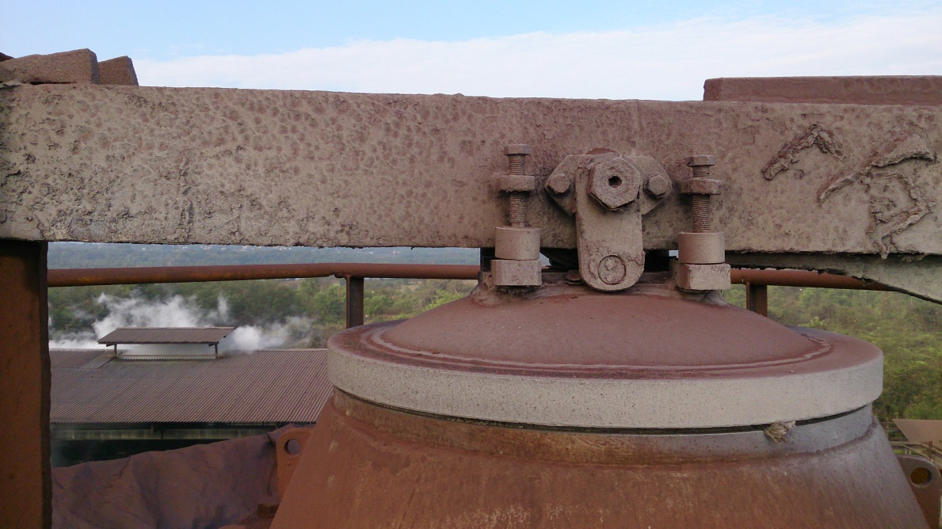
Cap
Main Lever
Seat

b) Check the lever and locking link are in line and touching the Body at Plate provided.

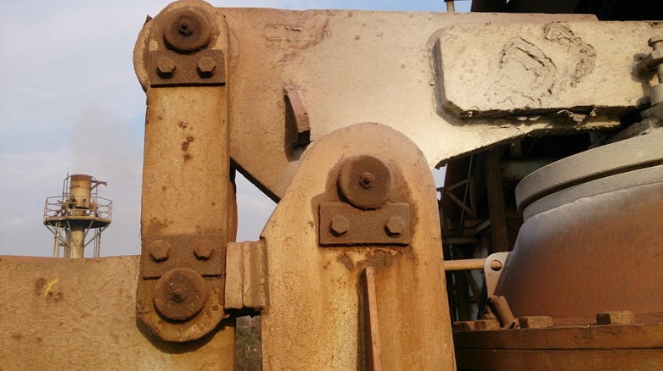
Locking link
Main Lever
Locking link should touch this plate provided on body

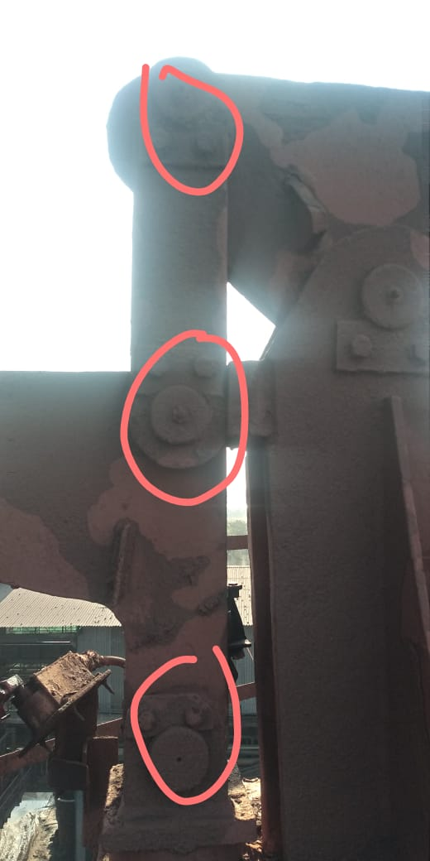
All three points of locking link should be in a straight line in close condition.

Work No 21: Hot blast valve bonnet replacing

1. This activity has to be taken up during shutdown of blast furnace.
2. Check the hoist for operation, whether hoist can move to extreme and also wire rope condition.
3. Take work permit from production for changing of valve bonnet & electrical s/d for HBS power pack
4. Ensure that the stove is isolated and withdrawn from PLC auto mode.
5. Water seal the respective stove and also steam purge the gas line.
6. Keep the respective hot blast valve in open condition (Resp Prod) and manually lock the valve by welding horizontal (Angle 65x65) stopper both sides.
7. Keep HBIV in closed position so as to prevent gas from coming out after the valve is removed due to back drafting from furnace
8. Close the main shut-off valve of respective stove in power pack and put Mechanical isolation lock on it.
9. Take Electrical Isolator shutdown of HBV, HBIV
10. Close cooling water valves of hot blast valve disc and remove the hoses and 40 NB lines of disc, keep bonnet valve in on condition
11. Remove the limit switches of the valve. RespElectrical
12. Remove hydraulic hoses, mark the direction on the hoses for opening and closing and also plug the hoses and cylinder ports.
13. Collect oil in the can while opening the hoses.
14. Remove the counter weight of the hot blast valve so that the weight of the valve reduces. Ensure that the counter weight is properly slinged using belt sling. Place the counterweight safely on the hot blast valve platform
15. Loosen bolts of the valve bonnet (M20X90) and punch those bolts out Keeping 4 no's bolts at corner.
16. Sling the valve using 25mm, 2mts long sling and the valve lifting arrangement for lifting the valve.
17. Keep the chimney valve of the respective stove in open condition so that sufficient negative draft is maintained to prevent hot air from coming out after the valve bonnet is removed.
18. Loosen the remaining bolts kept at the corners and punch them out.
19. Slightly tighten the sling so that the load of the bonnet is taken by the hoist.
20. Slowly lift the bonnet. While lifting the bonnet, ensure that there is sufficient gap between the structures and there is no fouling with the structures.
21. Lower the hot blast valve bonnet and shift it to nearby available free space and barricade it.
22. Remove the valve bonnet out of the HBS complex with hydra.
23. Check the condition of the valve wedges which is welded inside the valve body.
24. Check the condition of bonnet flange rope and replace it if required.(SS braided graphite asbestos rope)
25.
26. The spare HBV should be kept in open condition with the disc kept locked by welding stopper.
27. Remove the counter weight of the new/overhauled HBV and flange bolts (M20X90). And also cylinders if required.
28. Slowly lift the valve bonnet by proper slinging using Hydra and shift it near to the stove 1 below the hoist crane.
29. Slowly lift the bonnet by hoist crane and place the bonnet on its position. While doing this, ensure that the bonnet is placed in the right direction.
30. Connect the cooling water lines, hydraulic cylinders, and hydraulic hoses and limit switches.
31. Put the counterweight and chain for the new valve and remove the stoppers by gas cutting.
32. Check the cooling water flow through the outlet pipe.
33. Give clearance to electrical for fitting of limit switches.
34. Lubricate the valve, chain and sprocket
35. Clear electrical shutdown of the valves.
36. Remove the Mechanical isolation lock and open the shut-off valve in hydraulic power pack.
37. Open the inspection flange at the bottom of the valve. Take trials of the valve and check for full closing of the valve through the inspection flange. Initial operation is to be done by inching only. Do necessary limit switch setting to ensure 100% closing and opening of valve disc.
38. Give clearance for furnace startup.
39. Check for any leakages after startup.
40. Check the tightness of all bolts once again after 1 hr, 4hrs and 8 hours.

Work No 22: CPV spring support (Jelly-Belly Washer) Changing.
(To be done only during furnace shutdown)

- Take work permit from production.
- Take Electrical shutdown of CPV and latch in closed position.
- Close the Latch and Cap ball valve in hydraulic power pack and put the mechanical isolation lock on it.
- Remove the hydraulic cylinder fork pin from the Lever.
- Take the lever out from position by removing the pins of the lever connecting spring support and locking link. care should be taken while handling the lever (approximate. weight :- 40 Kgs)
- Remove the spring support (Jelly-belly washer) and replace it with new one.
- Connect the lever and cylinder back in position. Ensure pin locking is done by plate as earlier.
- Clear electrical shutdown and take trial with production.
- Remove the Mechanical isolation lock and open the valve in power pack.
- Clear the permit and give clearance to production.

Work No 23: APH/GPH pipes cleaning during SD
To be done only during plant shutdown after water sealing of stove Gas line and steam purging.

Entering into is a confined Space Activity. Below mentioned procedure to be followed

FOR MORE DETAILS REFER CENTRALISED CONFINED SPACE ENTRY SOP-VL/IMS/VAB/SP44 Y
Entering into is a confined Space Activity. Below mentioned procedure to be followed
Confined Space Checks before job start up:

- Before Entering in Confined Space ensure –
- Inside temperature should be less than 40 degree Celsius.
- CO Level should be 0 ppm
- Attendant must ensure proper illumination, if illumination not found ok, he must inform concern electrical person to provide hand lamp or halogen.
- Take the work permit from production-in-charge, Safety, electrical, mechanical for entering Confined Space.
- The workmen (Entrant) who is trained and certified by SBU Head and having valid confined space gate pass should perform the activity and he can be replaced(in emergency) only by certified entrant .
- A standby (attendant) who is trained and certified by SBU Head and having valid confined space gate pass should perform the activity and he can be replaced(in emergency) only by certified attendant .
- Standby person who shall be positioned outside the confined space , must have no other duties other than monitoring people and conditions inside the confined space and coordinating with rescue personnel (he must have contact number of rescue team members) if required.
- Standby (Attendant) person has to log down the In/Out entry of all entrants and ensure that entrant should be come out after 30 minutes from confined space for normal jobs.
- In some cases In/Out time may be relaxed /extended based on the risk involved in the particular confined space.
- Check Internal atmosphere of the space for sufficient oxygen content (19.5% to 23.5 %) flammable gases and vapours, and the potential for toxic air contaminants by the use of multi gas detector, if required use pump with extension before entering. If there is any deviation, do not enter into confined space.
- Check for the presence of Chemical asphyxiates such as Carbon monoxide (CO gas detector).It should be 0 PPM
- Check inside temperature and it should be is in the tolerable range (25 deg C to 45 Deg C). If the temperature is not within limits then appropriate ventilation to be used to normalize the temp.
- Check for suitability of equipment that is used at the confined space.
- Check any dust due to which visibility is reduced or respiratory tract is irritated.
- The sign-in and sign-out of all persons entering into confined Space should be recorded.
- Use 24V DC supply illumination to avoid electrocution/electric shock.
- Cutting or welding jobs inside the confined space should be carried out after checking for any explosive environment (LEL should be <10%) and by providing localized suction or heavy duty exhaust systems to prevent accumulation of gases inside the space.
- Isolation of related equipment of respective confined space with personal LOTO lock to be Ensured.
Please note that this area is considered as Confined Space so needs to maintain the checklist of the activity. All In time and out time details of entrants, levels of gases to be logged in checklist (yellow copy) or in any alternate document and to be documented.

Role of Rescue Team
As the work is being carried out inside confined Space, in an emergency victim can be taken out by use of rescue apparatus such as stretcher. However attendant should call ambulance which is fully equipped. However rescue team members should take a charge of the situation.

- Take work permit from production for changing of valve.
- Ensure that the stove is isolated and withdrawn from PLC auto mode.
- Water seal the stove and also steam purge the Gas line.
- Put Blank above the stove water seal.
- Open the inspection door of the inlet intermediate duct and bottom sump as required by the production.
- Give clearance to production for cleaning.
- After production completes cleaning and gives clearance, change the gasket rope of the inspection door and close the same.
- Remove the blank of water seal.
- Ask production to steam purge the line to check the flange/inspection leakage if any.
- Clear work permit, and give clearance to production.
- Check for gas leakage from inspection door/ water seal flange after startup.

Work No 24: Chimney valve Top bonnet replacement.
1. Take work permit from production for changing of valve.
2. Isolate stove of which chimney valve is to be replaced. Ensure that the stove is isolated and withdrawn from PLC auto mode.
3. Take all valves electrical shutdown (to be done for CBV,CBBV,GSV,GSSV, CASV and HBV)
4. Close the hydraulic power pack stand shutoff valve of respective stove with main shut off valve of the stand and put the Mechanical isolation lock on it.
5. Keep chimney valve open and lock chimney valve stem at top by welding to avoid seat getting moved during dismantling
6. Remove and loop the hose pipe connections of chimney valve. Mark the direction on the hoses for opening and closing and also put plug for the hoses.
7. Collect the oil in the can while opening the hoses.
8. Remove the hydraulic cylinders of chimney valve.
9. Remove the counter weight of the valve.
10. Dismantle top platform of chimney valve so that CV can be removed without any obstructions.
11. If required, remove the HBS barricading so that the there will be more clearance for moving the crane.
12. Loosen all bolts of CV top bonnet flange and sling the top bonnet to crane by using valve lifting beam arrangement.
13. Ensure that production isolates one stove and other stove is taken on blast and ID fan is stopped before lifting CV bonnet.
14. In above condition, with coordination of production, remove top bonnet and cover lower body with 3 mm plate and give clearance to take isolated stove in ON Gas
15. In this condition, clearance can be given to production to take other stoves ON GAS and ON BLAST.
16. Repeat step no. 13 to clean flange for putting gaskets. Ensure that cleaning is not carried out by standing above valve opening. Cleaning to be done from sides.
17. Measure distance of guide bars from disc seat and adjust/align guide distance accordingly. (If guides are not aligned as per distance it may damage/bend stem).

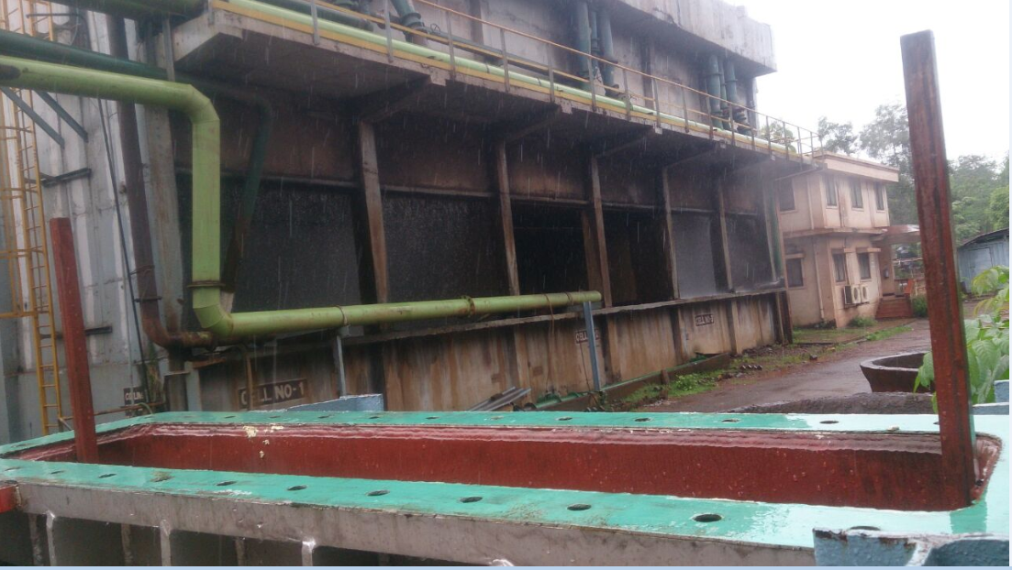
Guide Bars

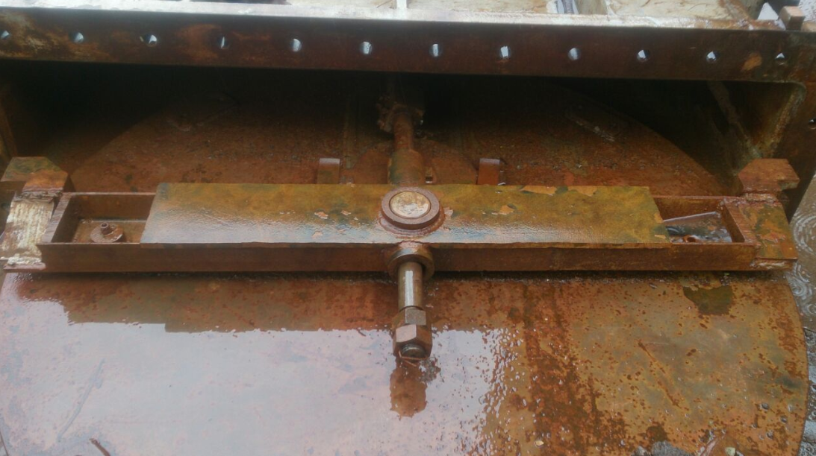
Guide Follower

Distance between Guide bar and flange to be maintained in Guide follower distance, otherwise valve stem will bend.

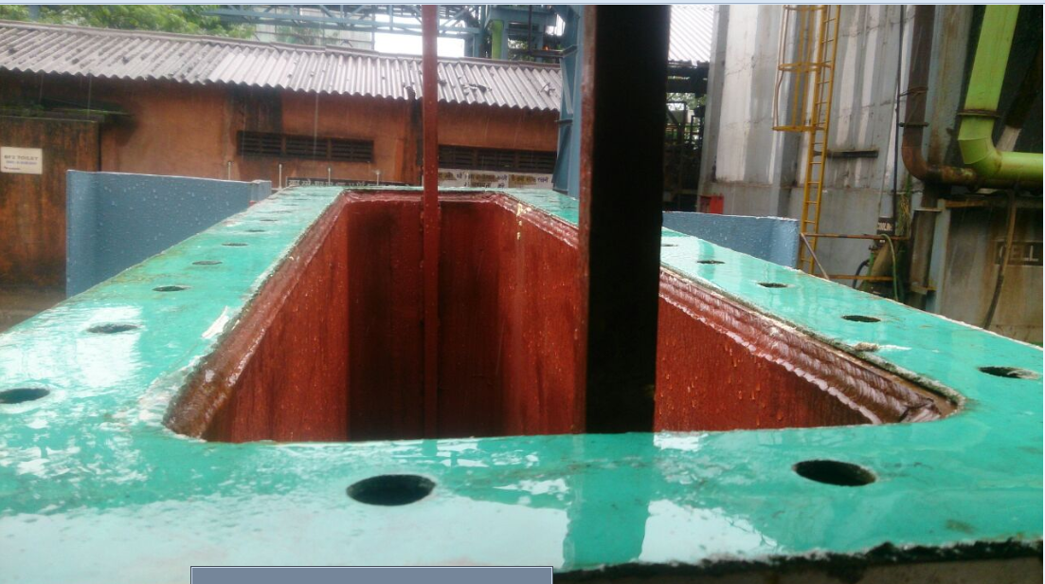

18. Check welding of the guide and guide seat.
19. Repeat step no 13 to fit the spare bonnet of the valve back in position.
20. The bottom inspection flanges of the valve should be kept in open condition so as to check proper movement of guide on the guide bar/seating of wedge on the wedge. also check seating of the disc on the seat.
21. Once the valve is fitted in position and flange bolts are tightened, clearance can be given to production to take the other two stoves on blast and on gas.
22. Tighten all the bolts, install cylinders, fix the hoses, and limit switches and platform.
23. Put back the hydraulic pipeline after ensuring that the pipe is not chocked. The pipes should be clamped properly to avoid jerking during operation.
24. Check for proper tightness of the wedge seat flange at the middle of the valve.
25. Install the counterweight for the new valve.
26. Clear shutdown, open the manual valves in power pack, and remove the locking arrangement provided for the other valves and take trials in presence of production, electrical and instrumentation.
27. Set the limit switches for port valve closing, port vale opening and disc opening.
28. Check disc while setting valve for fully open and fully closed condition.
29. Port valve, which equalizes the stove pressure, must be set for full opening and full closing. While setting, ensure that the disc doesn’t get lifted up from its seat until the port valve full open limit switch gets cut.
30. Take trials 4 to 5 times and ensure that valve disc is moving in the guide bar.
31. Weld stoppers to prevent the valve from overtravelling from fully open and fully closed positions.
32. Once the trials are over, clear the work permit and inform production to take stove in line.
33. After taking the stove on line, check for leakage through the flanges and wedge seat flange. Checking will have to be done when the stove is ON BLAST as pressure will be high during this time. Also check for oil leakages from hydraulic cylinder and pipeline.
34. Keep the stove in ON BLAST condition along with the other stove which is previously ON BLAST for 15 minutes. If there is no leakage, then isolate the other stove.
35. Check the bolt tightness once again after 2 hours.

1. Carry out the housekeeping activity as per WI/MAINT/91.
1. Refer work procedure WI/MAINT/12 for handling valves and filter.
2. Welding procedure as per SP 44
3. Please refer WI/MAINT/94 for fabrication, erection and dismantling
4. Use certified cutting torch set.
5. Use certified slings, D-shackles, Grinding M/c, etc
6. Do not stand below the load when it is hoisted.
7. Use all PPE-s
8. Use proper tools like spanners.

DO :

✓ For working on gas valves water seal respective stove and purge the steam.
✓ Take CO detector and monitor the CO level continuously while working on valves and gas line
✓ Inform Boiler department, when the soot blowing is being done.

DO NOT

❖ while bleeding water do not keep your face over the valve as it may injure your eyes.
❖ Stand below hoist
❖ Come in front of hot duct
❖ Lift the hoist without removing all bolts and made the valve/ bellow free

Amendement Record
Date | Manual Section Ref. & Para | Brief details of Revision | New Rev.

Prepared By:  Area Engineer | Reviewed & Issued By:  Management Representative | Approved By:  Mechanical Head
Signature | Signature: | Signature:
Review Date: 12.12.22 | Review Date: 12.12.22 | Review Date: 12.12.22

